Showan Simkhada

17459655

Quiz Nepal

The name of my application is Quiz (History of Nepal). There are 10 questions in this quiz. The prototype UCD of my app is shown as below: -

 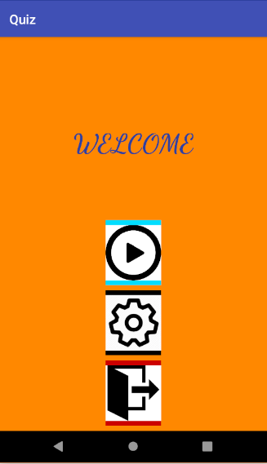

Splash Screen Menu Screen

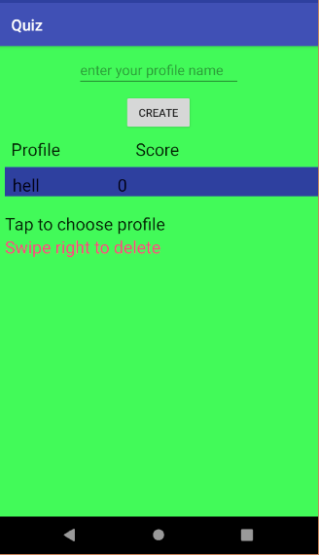 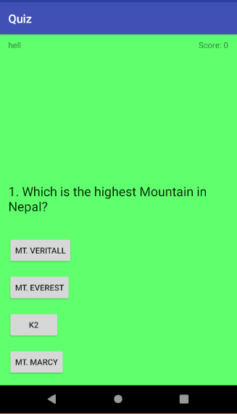

Profile Screen Quiz Screen

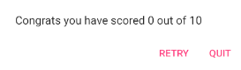On quit action it will kill the app.

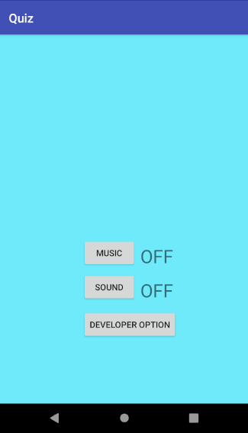

Setting Screen